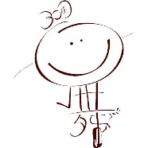
Agnes Huang School of Ballet (Kowloon)

Address: G/F, 49&51 Nam Kok Road
Kowloon City, Hong Kong
Email: agneshuangschoolofballet@gmail.com

For ENROLMENT: 27121398

Broadway Star  (3-5 years) | Tue 5:30–6:30p.m
Dance Super Tot  (2-3 years) | Tue 2:00–2:30p.m.
 | Fri 5:00–5:30p.m.

